Introduction
A university has committed to a programme of digital transformation for each of its schools (Law, Business, Sciences, Humanities) and each of its corporate functions (Admissions, Accommodation, Student Services, HR, Finance and Marketing).
This transformation involves the automation of existing processes and the introduction of new services and new ways of working. The University works in academic years i.e. September to August and the Vice Chancellor is keen to see progress each term (Autumn/Fall; Spring; Summer) throughout the year.
Organisation Structure
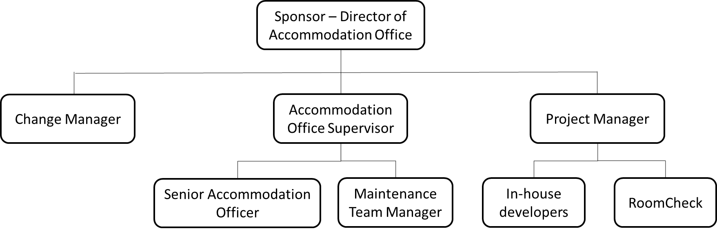
Roles and responsibilities
Sponsor - Director of Accommodation Office but they sit on a transformation board led by the director of digital transformation.
Change Manager - you are responsible for all of the business changes taking place in the Accommodation Office. You work closely with your counterparts in Admissions, HR, Finance, Marketing and Student Services.
Project Manager - Tom leads a small in-house development team familiar with the existing Accommodation Office systems, which are over 10 years old. He also manages the relationship with the external supplier RoomCheck.
Senior Accommodation Officer - responsible for IT systems, capacity planning and allocation policy. She will be the liaison with the IT developers.
Accommodation Office Supervisor - manages the staff and is responsible for all procedures, quality standards and performance management. She will develop the new ways of working.

Example documentation
Description of the change
The purpose of the description of the change is to create an understanding of what will be different in the future. The scope of the change will define the number of people participating in the change and the ability of the change initiative to destabilize the business-as-usual environment.
Vision:
There is a single record of all accommodation related information, created by entry of data from all relevant stakeholders via simple, intuitive front-end apps. Access to information is via authorised login on a collaborative platform, preventing local copies of data being held by individual users. This information is used for auto-allocation of accommodation to students and maintenance issues to be resolved and it is to be enhanced via two-way interfaces that enable immediate notification of latest availability and status of accommodation data.
Scope and exclusions
The services of the Accommodation Office continue to evolve, widening from student and academic accommodation in the first year, to servicing all students in any year of their study, including summer school students.
Properties under management include buildings owned or leased directly by the university and accommodation owned and managed by private landlords and commercial lettings agents.
It is not anticipated that the Accommodation Office will make these changes in the way lecture rooms are allocated to subjects. This responsibility will remain with each of the schools and colleges within the university.
Deliverables
There will be a need for front end applications to be developed for data capture by staff and students. Links to the existing system holding all accommodation related data will be needed and a replacement of the existing legacy system is also to be considered. Changes to processes used by staff in the Accommodation office and other functions that provide input to or are users of information from the Accommodation Office (e.g. Admissions and Scheduling) will be required. Students will need to be made aware of their new responsibilities and the processes they are expected to follow.
Maintenance staff will receive notification of repairs via an app that they will also use to capture data about the repairs they have made and other issues they notice about the property.
Links to other initiatives
Digitisation is taking place in all functions within the university and changes in the Accommodation office will need to align with changes elsewhere. For example, Admissions are no longer sending welcome packs via the post to new students, so forms to enable students to book accommodation in their first year will not be sent out in this pack as they have been in the past.

