Timeframe
The duration of this phase of the digitisation of the Accommodation Office is one year, which aligns to a typical planning cycle for university initiatives, based on an academic year starting in September and finishing in August.
As we are at the start of the initiative, there are detailed activities for Iteration 1 and 2, with a description of the outcome for iterations 3, 4, 5 and 6.
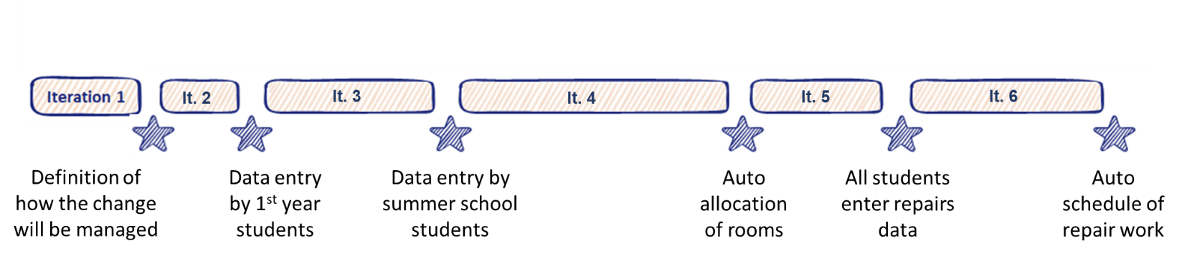
Iteration 1
This is the work to define the project, including the creation of the 5 suggested documents:
- Description of the change
- Business Case
- Change Management Strategy
- Change Plan
- Communications Activities/Plan
Time allocated to Iteration 1 is used to hold workshops to brainstorm and decide upon the content for these documents.
Iteration 2
As this is only the first iteration where changes will be created, it is advisable to pick a straightforward, small-scale output. For example:
Scope:
An application will be developed to enable students to enter their room requirements on-line. This will remove the need for forms to be sent to students, and the data entered manually by Accommodation Office staff.
The application will be available to first year students only who are offered rooms on the university campus.
Exclusions:
If there are excess rooms, 2nd and 3rd year students are offered this accommodation, but this is a separate process to the allocation to 1st year students.
This application will not connect with the existing database which holds all details of all buildings, rooms, and fittings.

In the Discover step of Getting Started for Iteration 2, all those involved in this work will brainstorm the activities required to create the tangible and behavioural change that will enable a successful deployment of the agreed scope.
In the Plan step of Getting Started for Iteration 2, these requirements will be prioritized using the MoSCoW prioritization technique and the work allocated to those participating in this iteration of the change.
For example, the requirements identified in the Discover step could include:
- Review the existing Accommodation Application Form to identify the data fields for the application
- Identify common and exceptional room booking scenarios to be managed by the application
- Create a storyboard of the screens that form the application
- Re-design the role descriptions for those Accommodation Office staff who will no longer work on manual entry of data
- Arrange for the application to be available from Apps/Play stores for Apple and Android devices
- Create communications to potential students explaining the availability of the application and how to access it

Iteration 3
To further exploit the functionality of the application, its use will be widened to include summer school students who require rooms for a duration of 2 weeks to 3 months from June to August each year
Iteration 4
This will be the first time the existing systems will be amended, creating a direct feed from the application to the Accommodation Office database, to enable the automated allocation of rooms, matching the requirements via a new algorithm.
Iteration 5
This iteration broadens the on-line offering of the Accommodation Office, in line with the overall objectives of the digitisation programme. Currently students must report any repairs needed (blocked drains, broken locks and windows etc) to the Accommodation Office in person, during office hours. They fill in a form and this data is input by an Accommodation Officer. This process will be replaced by an extension of the information that can be collected by the application available to students.
Iteration 6
Using the connection to the existing Accommodation Office database created in Iteration 4, on-line repairs information will be used to allocate the jobs direct to the Maintenance Team.

